**MesoCam operating instructions**

**Introduction to the software**

**Launch Software**

* Double click the MesoCam icon on the desktop. The MesoCam user interface is seen in figure 1.

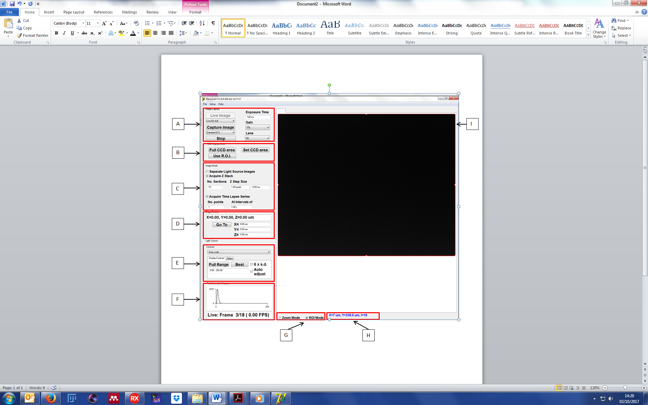

Figure : MesoCam user interface.

**Identifying Main Features**

**A: Image Capture**

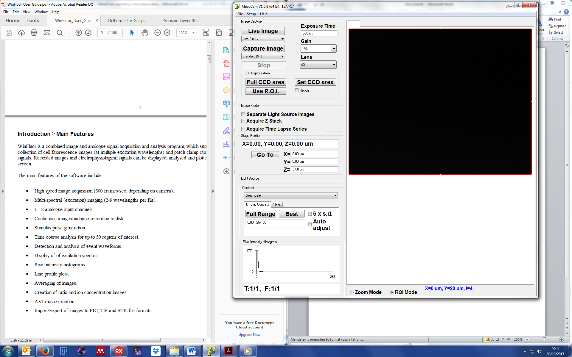

Figure : Image capture options.

**Live Image:** Click live image to display a real-time image of the specimen.

**Live Bin:** This sets the binning of the live image displayed. The default is set to 1x1; there is also 2x2 and 4x4 available. Higher binning modes (2x2 and 4x4) increase the image capture rate allowing easier focusing/viewing.

**Capture Image:** Click to begin image capture

**Pixel shift:** This selects capture mode. The default is set to no pixel shift (**Standard(1X1)**); there is also the option for 2x2 pixel shift (**Hi Res(2x2)**) and 3x3 pixel shift (**Hi Res(3x3)**). Pixel shift imaging increases the spatial resolution of the image by acquiring a grid of sub-images shifted by a fraction of a pixel (1/2 pixel  in 2X2 mode, 1/3 pixel in 3X3 mode and interleaving them into a high resolution image. **See notes for resolution details.**

**Stop:** Click to stop the camera. Can be pressed to stop live view or during a capture to cancel.

**Exposure time:** Can be set between 0.01ms and 7000ms (10µs to 7s). Enter required value and click enter.

**Gain:** This can be set between 0 and 100. Choose from the dropdown menu. Increasing the gain increases the brightness of the image for a given exposure time. (Note. Increasing the gain also increases image noise so increasing the exposure time is a preferred option for increasing image brightness).

**Lens:** Selects the objective lens in use. (Note. Only one X4 Mesolens is currently available.)

**B: CCD capture area**

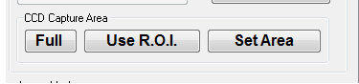

Figure : CCD capture area options.

**Full:** Click to capture images from the full CCD imaging area,

**Use R.O.I.:** Click to crop the imaging area to the region of interest defined by the red user drag-able ROI rectangle on the live display.

**Set Area:** Click the **Set Area** button to define the imaging region by entering the X and Y dimensions (as a % of the full CCD dimension) into the **X Range** and  **Y Range** fields in the Set CCD Area dialog box. Click the **OK** button select the sub-region.

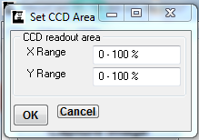

**C:** **Image mode**

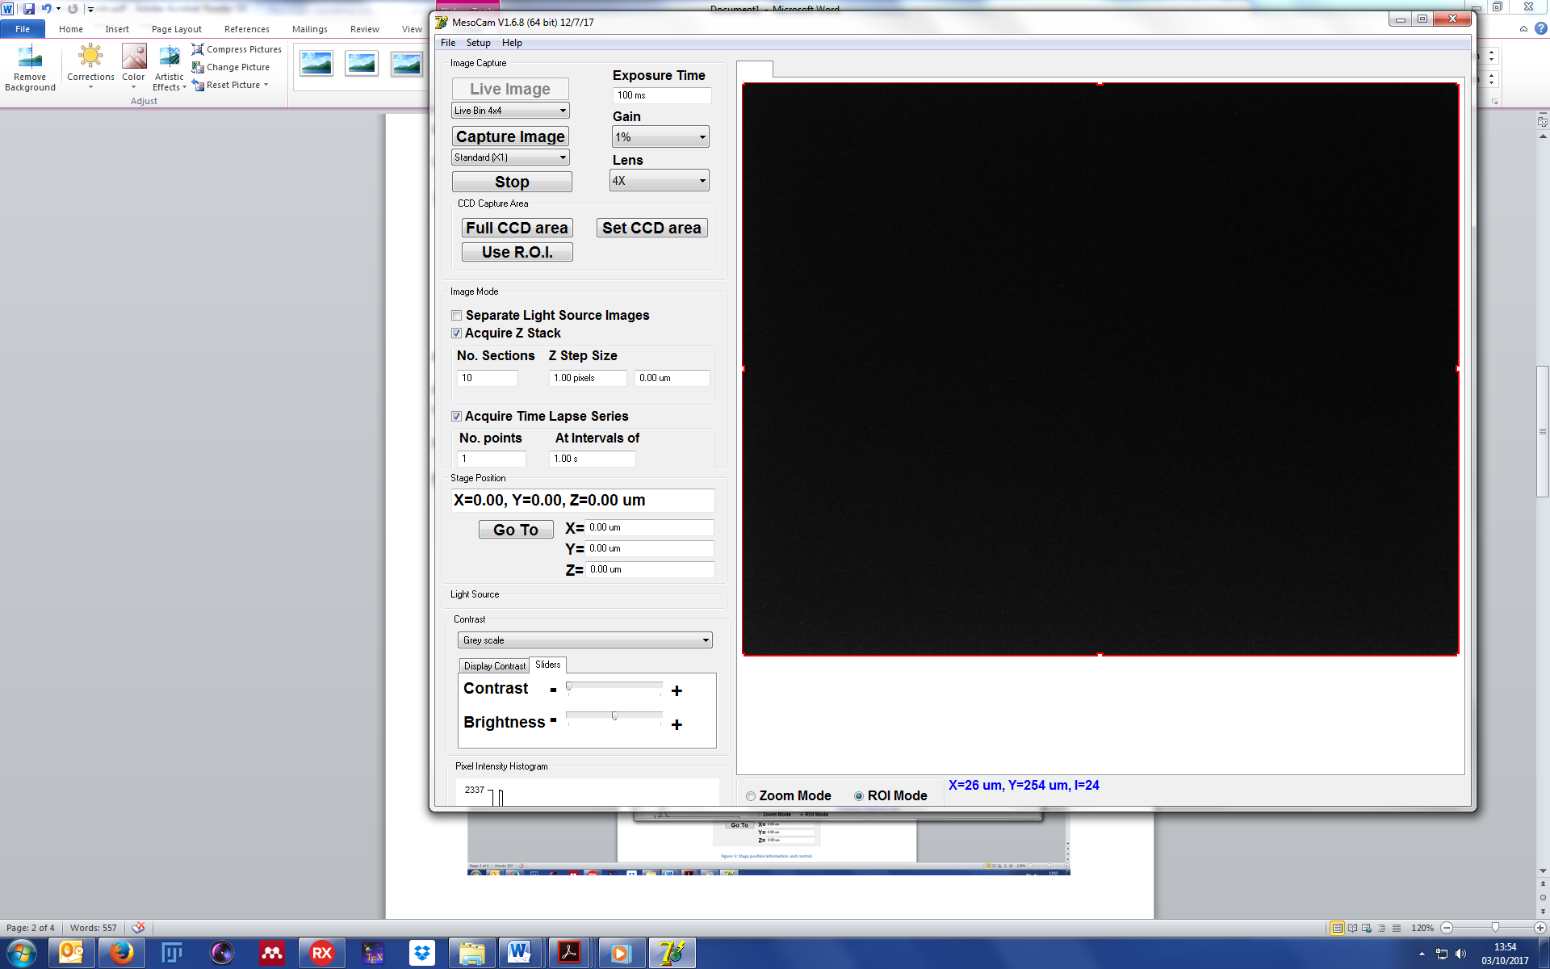

Figure : Image mode options.

**Separate Light Source Images: Feature not in use.**

**Acquire Z Stack:** Allows the user to image a volume. When checked, the sub menu will be displayed, seen in figure 4. **No. sections** and **Z step size**. Number of sections is the number of planes you would like to image. Z step size is the distance between each plane. It can be entered in the pixels text box or µm text box (**Recommended input in the µm text box and press enter)**.

**Acquire Time Lapse Series:** Allows the user to capture a time lapse. the sub menu will be displayed, seen in figure 4. **No. points** and **At intervals of**. No. points is the number of images you want to take. At intervals of is the time delay between each image (**input in seconds and press enter**).

**D:** **Stage position**

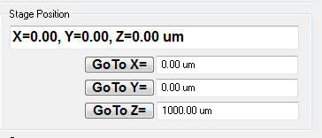

Figure : Stage position information and control.

**Stage position readout:** This reads directly from the stage controller and is displayed in µm.

**Go To X= :** To move the stage to a selected X axis position, enter the position (microns) into the **Goto X=** field then click the **GoTo X=** button (or press the Return key)

**Go To Y= :** To move the stage to a selected Y axis position, enter the position (microns) into the **Goto Y=** field then click the **GoTo Y=** button (or press the Return key)

**Go To Z= :** To move the stage to a selected Z axis position, enter the position (microns) into the **Goto Z=** field then click the **GoTo Z=** button (or press the Return key)

**E:** **Contrast**

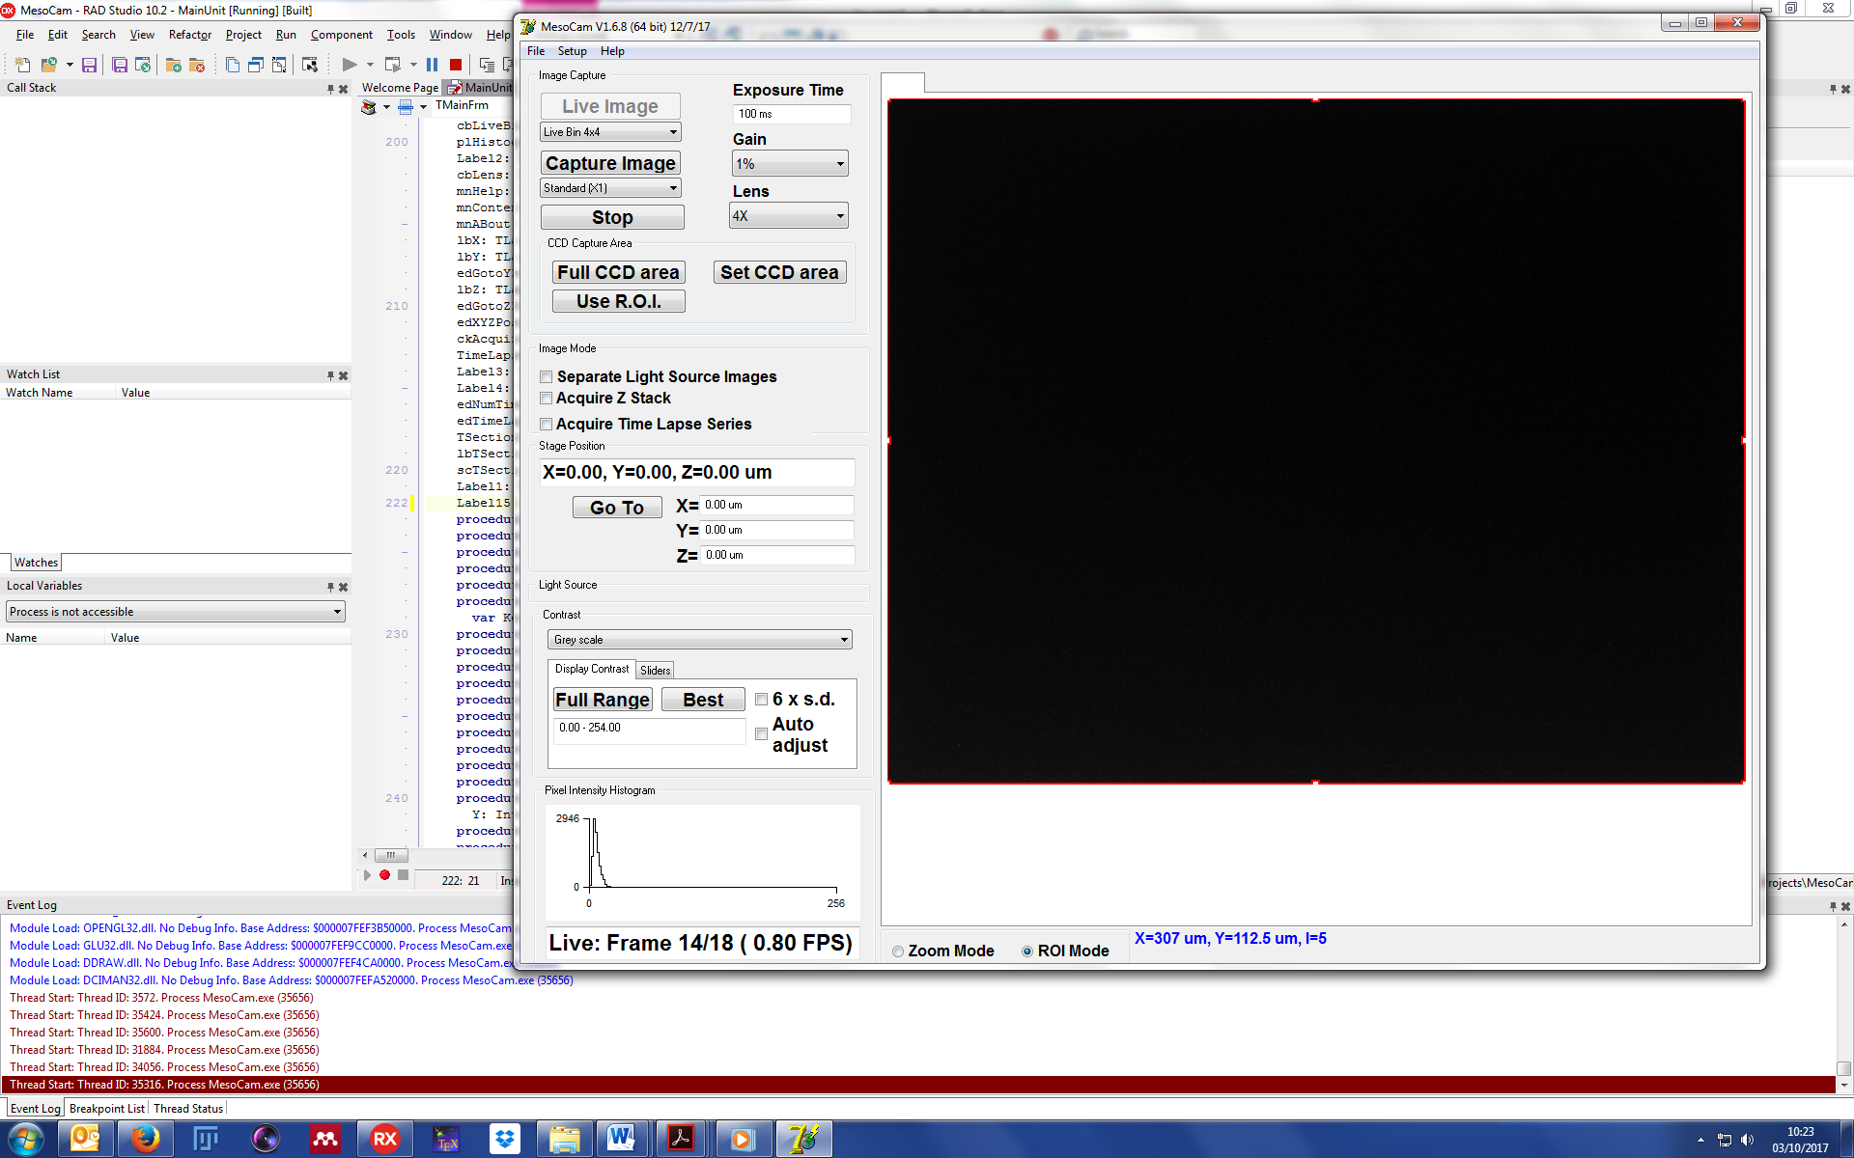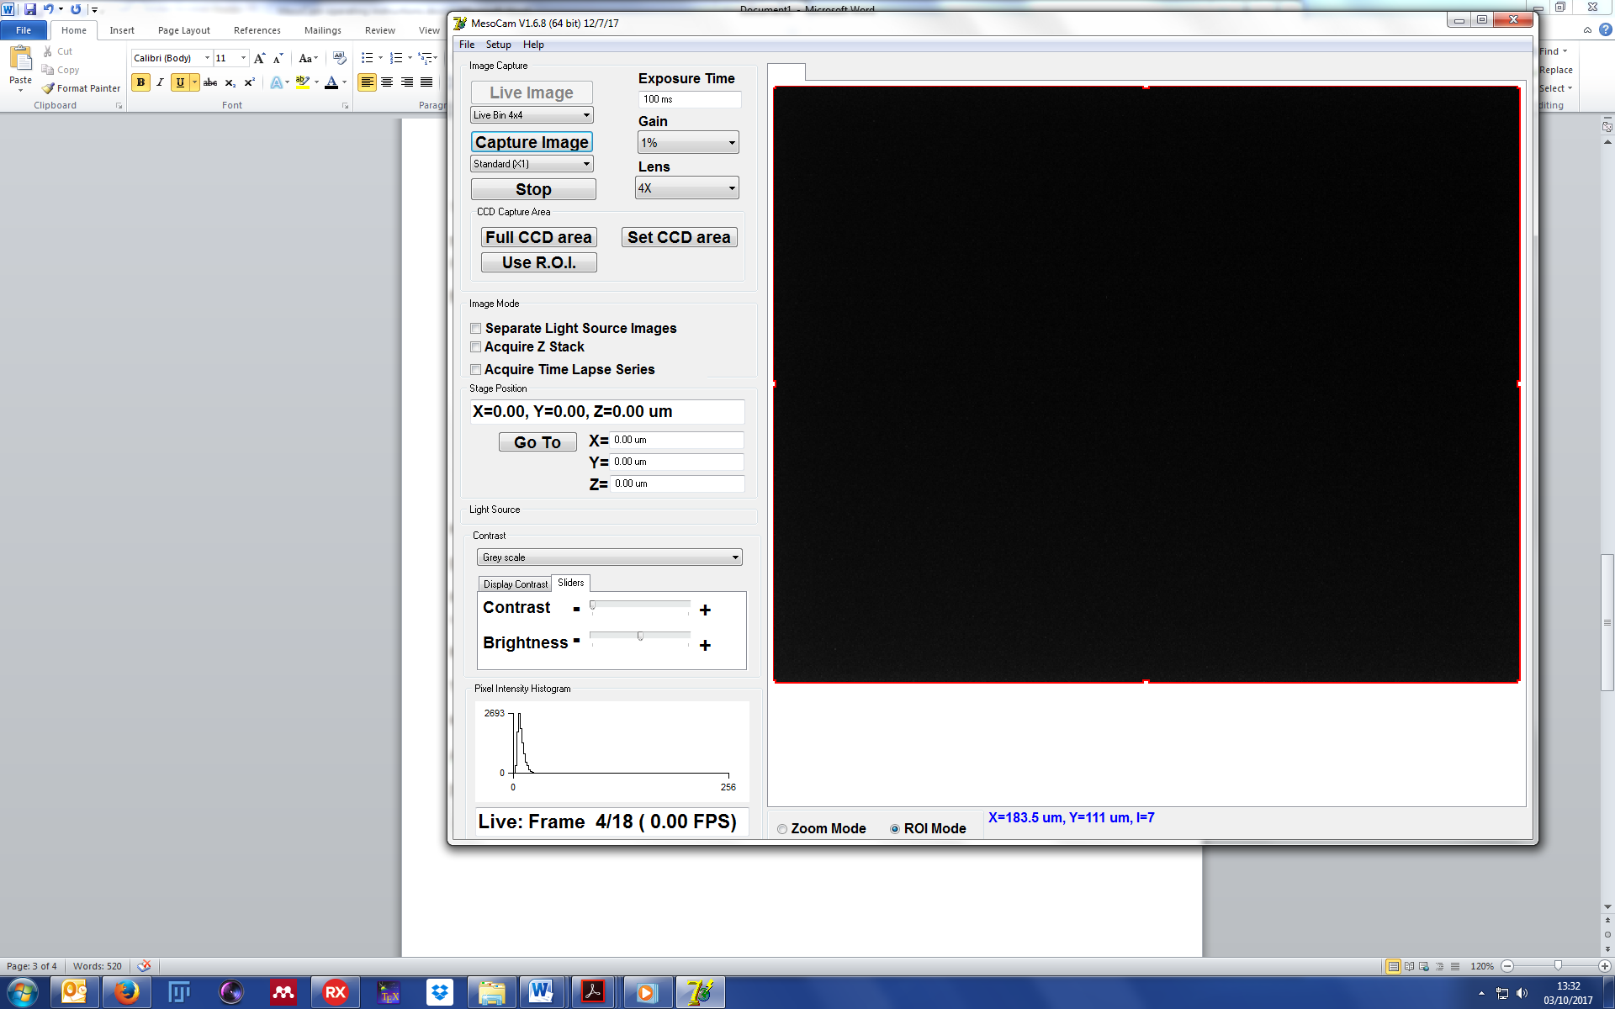

Figure 6b: Contrast sliders tab.

Figure 6a: Display contrast tab.

**False colour overlay:** Select to change the colour overlay on the image. The default is **grey scale**. There is also **red scale**, **green scale** and **blue scale.**

**Display contrast tab**

**Full range:** The default selection and displays the full range of intensities available for the camera. For the Stemmer camera this is 12 Bit (0-4095).

**Best:** Click to set the optimal brightness and contrast for the range of pixel intensities within the currently displayed image.

**Text box:** Dynamic range output. Can be entered manually while focusing the specimen. Type in range in the format of **n1 – n2** and press enter. Where n1 is the lower value and n2 is the upper value.

**6 x s.d.:** Tick the **6 x s.d.** option, to make the **Best** button optimise brightness and contrast to display the range of pixel intensities plus or minus 3 standard deviations of the mean pixel intensity.

**Auto adjust:** Tick the **Auto adjust**  option, to optimise optimal brightness and contrast automatically whenever a new image is displayed.

**Sliders tab**

**Contrast**: Slide to adjust contrast of displayed image.

**Brightness:** Slide to adjust brightness of displayed image.

**F:** **Histogram**



Figure : Pixel intensity histogram and camera readout.

**Pixel intensity histogram:** intensity distribution of the image displayed in the main window.

**Camera readout:** Will display if the camera is in live view. When capturing an image the information will be displayed here.

**Image Display**

**H:** **Mouse hover**



Figure : Mouse hover information.

Hovering the mouse over the CCD area during live view or when an image is captured will give a readout of pixel information. **X:** the lateral pixel position, **Y:** vertical pixel position and **I:** pixel intensity.

A region of interest (ROI) can be selected by adjusting the bounds of the red rectangle superimposed on the displayed image .

**Left Mouse Button (Zoom In):** Click the**left mouse button** to zoom in on a magnified region of the displayed image centred on the mouse position. To move the zoomed region within image, hold the mouse button down and drag the display.

**Right Mouse Button (Zoom Out):** Click the **right mouse button** to zoom out, to revert to displaying a wider region of the image.

**Using the software**

Save image

Capture image

Optimise image intensity values

Adjust focus

Real-time view

**Capture a single image**

**Real-time view:**

* Click **live image.**
* Ensure the **prism** is removed from the light path.

**Adjust focus:**

* Set a short **exposure time** between 100ms and 500ms.
* Adjust the range of intensities for the displayed image using **best** or entering a range of intensity values in the **text box** if required, until the image displayed is visible.
* Use the wheel on the stage control to bring the specimen into focus.

**Optimise image intensity values:**

* Saturation occurs at 4095 intensity counts. An upper value of 3500 intensity counts is sufficient for imaging with the Stemmer camera.
* Adjust the **exposure time**, and/or **intensity of excitation light** to optimise image intensity values. Click best after each adjustment made to update the intensity value text box.
* Once you are satisfied with the intensity values, click **full range** to ensure you are happy with the optimisation.

**Capture image:**

* Choose the **pixel shift** option from the drop down menu (**See Resolution details for Stemmer**).
* Click **capture image**. The progress of the image capture will be displayed in the **camera readout** box.

**Save image:**

* Click **file.**
* Click **save image to file.**
* Choose the location you want to save your file And click **save.** The file type will be Tiff.

**Capture a Z stack**

**Acquire Z Stack:** Tick the **Acquire Z Stack** option to acquire a stack of images at a series of Z axis planes

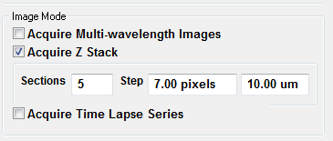

Enter the number of sections to be acquired into the **Section** field and the distance between sections into a **Step** field. The step size can be entered either as the step size in microns or as multiples of the camera pixel size.

**Capture Image:** Click **Capture Image** to capture a stack of high resolution images.

The Z stack begins at the current stage Z position with the stage position incremented by **Step** microns between images.On completion of the stack the series of images are displayed on screen with each plane selectable for viewing using and Z position scroll bar.

**Capture a time lapse series**

Tick the **Acquire Time Lapse Series** option to acquire a series of image at specified time intervals.

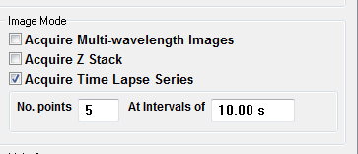

Enter the required number of images in the series in the**No. Points** field and the interval (in seconds) between images in the **At Intervals Of** field.

**Capture Image:** Click **Capture Image** to capture the time series of high resolution images.

On completion of the series, the images are displayed on screen with each plane selectable for viewing using and T position scroll bar.

**Saving Images to TIFF files**

To save a captured image (or image stack/series) to a TIFF file, select **File > Save Image** from the main menu to open the Save Image dialog box.

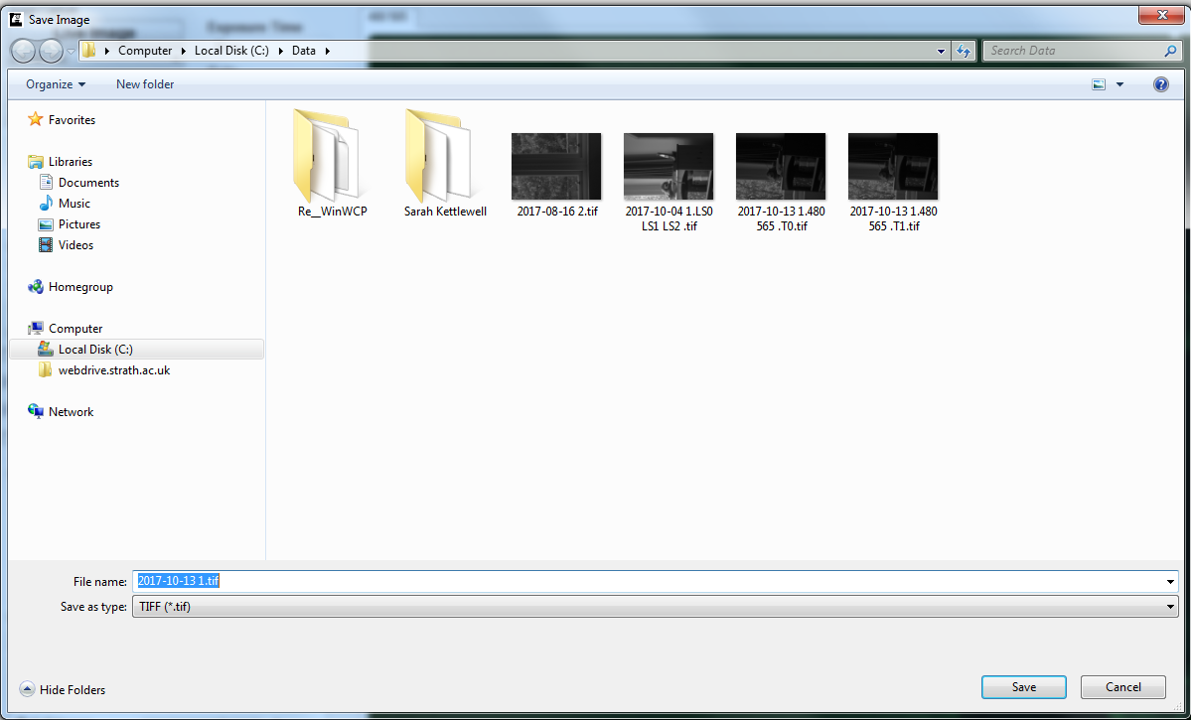

Select a folder to save the files(s), enter a name for the file then click the **Save** button.

Images are saved in OME-TIFF format.

**Saving & Displaying Images in ImageJ**

To save a captured image (or image stack/series) to a TIFF file and then open it using Image-J, select **File > Save to Image-J** from the main menu to open the Save Image dialog box.



Select a folder to save the files(s), enter a name for the file then click the **Save** button.

The image will be saved to the folder then loaded  into Image-J.

**Notes**

**Resolution details for Vieworks VMC-29MC-5M camera**

Values for the Mesolens with the 8x magnification lens attached and single image capture.

Field of View (FOV): 4.4mm x 2.9mm

No pixel shift:

* 6576 x 4384, 28.8 Megapixel.
* 1.486 pixels/µm
* 0.673 µm/pixel
* 0.05 GB

4x pixel shift:

* 13152 x 8768, 115.3 Megapixel.
* 2.973 pixels/µm
* 0.336 µm/pixel
* 0.23 GB

9x pixels shift:

* 19728 x 13152, 259.5 Megapixel.
* 4.425 pixels/µm
* 0.224 µm/pixel
* 0.51 GB